

An Undergraduate Internship/Project on Topic

**Blood Donor**

By

**Tonmoy Saha**

Student ID: **1610216**

**Summer, 2021**

Supervisor:

MD. Fahad Monir

Department of Computer Science & Engineering

Independent University, Bangladesh

**June 17, 2021**

**Dissertation submitted in partial fulfillment for the degree of Bachelor of Science in Computer Science**

**Department of Computer Science & Engineering**

**Independent University, Bangladesh**

# Attestation

This is to certify that the report titled “**Blood Donor**- A web based Blood Bank” was completed by Tonmoy Saha (1610216) submitted in partial fulfillment of the requirement for the Degree of Computer Science from Independent University, Bangladesh (IUB). It has been completed under the guidance of Md. Fahad Monir (Internal Supervisor) and Mr. Abid Ibn Habib (External Supervisor). I also certify that all my work is original and has not been submitted earlier to this university or any other institution. All the source of information used in this Project Report has been duly acknowledged in it.

_______________________ _______________________

Signature Date

# Acknowledgement

I am using this opportunity to express my gratitude to everyone who supported me throughout the course. I am thankful for their aspiring guidance, invaluably constructive criticism, and friendly advice during the internship. I am sincerely grateful to them for sharing their truthful and illuminating views on a number of issues related to the course.

I am grateful to Independent University, Bangladesh (IUB) for offering me this course and I express my thanks to my faculty and internship supervisor, MD Fahad Monir.

I want to stretch out my earnest gratitude to him. I am profoundly obligated to Independent University, Bangladesh (IUB) for their direction and consistent supervision just as for giving important data with respect to the course.

I am very much grateful towards my external supervisor, Mr. Abid Ibn Habib for his guidance and support that I needed for the fulfillment of my internship and project. I might want to offer my extraordinary thanks and gratitude to the JBL Drug Laboratories IT Department developers and employees for giving me such consideration and time and directing through the internship.

I also want to thank my parents for who have not only supported me financially but have always believed in me and always motivated me to accomplish the things that I achieved.

# Letter of Transmittal

Date:

Md. Fahad Monir

School of Computer Science and Engineering

Independent University Bangladesh.

Subject: Submission of Internship Report.

Dear Sir,

It is a great pleasure to submit my report on Internship at JBL Drug Laboratories. I have tried to narrate my project works, achievements and experiences in this report. All the works presented here are done with utmost sincerity and honesty.

During the internship period, I have served in JBL Drug Laboratories for three months where I have not only gained real life work experience but understood the process of the department and its various aspects. This report includes a detailed review of the office as well as the functionalities of the department. As a document of my effort during the internship periods I have conducted all the project works that I have done during my internship periods, especially their requirement, functionalities, and technical specifications.

I pray and hope this report will be quite interesting and fulfil your expectations. I have tried my best to avoid my deficiencies and hope that my report will satisfy you. I also would like to thank you again forgiving me the opportunity to submit this report.

Sincerely,

Tonmoy Saha

ID- 1610216

# Evaluation Committee

.....................................................................

Signature

.....................................................................

Name

.....................................................................

Supervisor

.....................................................................

Signature

.....................................................................

Name

.....................................................................

Internal Examiner

.....................................................................

Signature

.....................................................................

Name

.....................................................................

External Examiner

.....................................................................

Signature

.....................................................................

Name

.....................................................................

Convener

# Abstract

“**Blood donor**” is a web-based Blood Bank. It is a platform that creates connection between Hospitals (who has blood) and Receivers (who needs blood).​ My internship was to develop this project as a Non-Profit Project/Business by JBL Drug Laboratories Limited.

Firstly, the main duty was Brainstorming to come up with ideas to design the whole mechanism. It needed to be simple and also easy to use (user friendly). The website app was required to store all data in a database that was secured and could be accessed/edited by authorized persons only.

"**Blood Donor** - a web based blood bank" provides list of blood (available) and Hospital (who has these) in your area. A large number of blood donors and hospitals attracted using a Web Based application. Since almost everyone carries a mobile phone with them, it ensures instant location information and communication. So when people are having difficulties in terms of searching blood for their known one, this web-app will help to fulfill their needs in short time as managing blood in short time is a great factor sometimes.

This system needed to be automated by the users (customer & Hospitals) as a sustainable system that works smoothly without admin and management interruption or permission.

During working at **JBL Drug Laboratories Limited**, I was able to develop new skills and learned to work with new platform.

**Contents**

Attestation i

Acknowledgement ii

Letter of Transmittal iii

Evaluation Committee iv

Abstract v

Chapter 1 Introduction 1

1.1 Overview/Background of the Work 1

1.2 Objectives 2

1.3 Scopes 3

Chapter 2 Literature Review 4

2.1 Relationship with Undergraduate Studies 4

2.2 Related works 5

Chapter 3 Project Management & Financing 6

3.1 Work Breakdown Structure 6

3.2 Process/Activity wise Time Distribution 8

3.3 Gantt Chart 9

3.4 Process/Activity wise Resource Allocation 9

3.5 Estimated Costing 10

Chapter 4 Methodology 10

Chapter 5 Body of the Project 13

5.1 Work Description 13

5.2 System Analysis 13

5.2.1 Six Element Analysis 13

5.2.2 Feasibility Analysis 14

5.2.3 Problem Solution Analysis 15

5.2.4 Effect and Constraints Analysis 15

5.3 System Design 16

5.3.1 Rich Picture 16

5.3.2 UML Diagrams 17

5.3.3 Functional and Non-Functional Requirements 17

5.4 Product Features 19

5.4.1 Input 19

5.4.2 Output 22

5.4.3 Architecture 27

Chapter 6 Results & Analysis 28

Chapter 7 Project as Engineering Problem Analysis. 31

7.1 Sustainability of the Project/Work 31

7.2 Social and Environmental Effects and Analysis 31

7.3 Addressing Ethics and Ethical Issues 32

Chapter 8 Lesson Learned 33

8.1 Problems Faced During this Period 33

8.2 Solution of those Problems 33

Chapter 9 Future Work & Conclusion 35

9.1 Future Works 35

9.2 Conclusion 35

Bibliography 36

# Chapter 1 Introduction

## 1.1 Overview/Background of the Work

Blood bank is a place where blood bag that is collected from blood donation events is stored in one place. The term “blood bank” refers to a division of a hospital laboratory where the storage of blood product occurs and where proper testing is performed to reduce the risk of transfusion-related events.

Blood bank storage and management involves keeping records of blood available as well as information regarding the donors of the blood and also hospitals and patients that are in need of the blood. Blood donation is a very delicate process and therefore, it should be managed and controlled with high caution. Managing this process has a very little margin for error, if it has any.

Blood is classified into four main types, each with its negative and positive variations. Other information relevant data like blood sugar content, antibodies, and so on are also necessary to while matching a donor to a recipient. Hence, there is an absolute need for these data and information to be stored and maintained with high security and integrity. Other relevant information include the donors primary test results.

Present day blood bank storage is file based. This means that data and information regarding blood, donors and recipients are kept in spreadsheets, papers and files arranged in alphabetical or numeric order. This makes data and information retrieval hard and time consuming. Donors test results are recorded on papers too. This makes the data susceptible to errors and human mistakes which in turn puts human lives in danger. Another problem with this system is the poor efficiency. The process of retrieving blood, donor or recipient information is a tedious process and takes a lot of time. Considering the hospitals’ and recipients’ needs and the urgency usually involved, this makes it hard for the hospitals and put the recipient’s life in danger. Data Safety, security and backup is also poor as the papers and files can be easily stolen, lost or destroyed. This makes it an unreliable system.

Computerized blood bank management system (BBMS) had been developed in previous years but are highly inadequate. The existing BBMS’s are mere storage systems that are mostly unusable by the hospital workers. They focus more on storage rather than coordinating management and operational activities and therefore are still yet to be accepted by the establishments. [7]

As you go into this paper, you will be introduced to a new solution that we offer after a careful study of relevant research and documents.

Blood Bank Management System (BBMS) is a web-based system that can assist the information of blood bags during their handling in the blood bank. With this system, the user of this system can key in the result of a blood test that has been conducted on each of the blood bags received by the blood bank. The result of the test will indicate whether the blood bag can be delivered to the patient or not.

From this system, there are several types of reports that can be generated such as blood stock reports, donor’s gender reports, and the total blood donation according to months and year. The system also can give information to the donor about blood analysis test results for each time the donor makes a contribution. Hence, BBMS will make the blood bank stock more systematic and manageable.

## 1.2 Objectives

The Blood Bank is a web application that is helping people during this pandemic 2021 on getting blood in emergency cases through this web application. We are indicating service on where people are allowed to put on requests to get the blood. The blood is checked and safe to use as it is certified from the hospital. Our web application is partnering with hospitals on giving the product to the people.

Our service also showcases which blood is available and a description of which blood can transfer to what blood group. In short form, any people with intentions to get our product can have better and fastest way. Our aim is that people in Bangladesh always need to look for blood through social media, for example, Facebook or Instagram. Now through our Blood Bank services, they will not need to seek help or wait for receiving the blood. As it is a new service we have built up through our JBL Drug Laboratories who are giving us the access and funding on creating this web application and so there are many more functionalities that will be added in the future for the betterment of Blood Bank.

For now, we are able to provide:

* Develop a feasible solution to handle management activities in blood banks.
* Create an effective means of communication between donors, hospitals, donors, and recipients.
* Device means of coordinating the activities of blood banks and blood donation centers.

## 1.3 Scopes

The scope of the web application is the following scenarios:

* All blood groups of blood
* Management of receiving authentic safety blood stock.

**Limitations:**

* The user will not have a direct connection with the donor’s information.
* The Hospital will be able to check upon the User’s information.

**Product Perspective:**

* To provide efficient blood stock management functions to the web application by recording the details.
* To provide immediate storage and retrieval of data and information.

**Web Application Features:**

* Login Interface by Hospitals and Patients.

1. Email address
2. Password

* Registration by Hospital

1. Hospital Name
2. Hospital City
3. Hospital Phone Number
4. Hospital Email
5. Hospital Password

* Registration by Receivers

1. Receiver Name
2. Blood Group
3. Receiver City
4. Receiver Phone Number
5. Receiver Email
6. Receiver Password

* Accept request or delete request option by the Hospital Management.
* Cancel blood donation request option by Patient before Hospital accepts.
* Add Blood group information from Hospital
* Add request of receiving blood from Hospital
* Show List of Available Blood Samples from Hospitals
* Health tips Page is a text format where giving ideas for people to be healthy and fit.

# Chapter 2 Literature Review

## 2.1 Relationship with Undergraduate Studies

This project is related to my undergraduate studies as I am from Computer Science and Engineering Department, I had learned coding of making various application. Some of the course where I can relate.

#### CSE 303 - (Database Management)

An introduction to database design and the use of database management systems. The course includes detailed coverage of the development process, database architectural principles, relational algebra and SQL using Oracle or SQL Server. Other key database topics covered are data modelling (E-R model, relational data model, integrity constraints, data model operations, normalization, object oriented data modelling), database security, administration and distributed systems.

#### CSE 309 - (Web Applications and Internet)

This course serves as a comprehensive overview of web technologies and their usage. Essential topics such as OSI & TCP/IP architecture, Internet Routing, IP addressing & Domain Name System will be covered. Discussions will be held on popular browsers, HTML and Cascading Style Sheet, HTTP, HTTPS, FTP, Client and Server side scripts, Scripting (JavaScript, AJAX, XML) with jQuery libraries, Web Servers (IIS, Apache). Students will learn to design dynamic websites using ASP.NET with SQL server and PHP with My SQL. A brief overview of topics in web security such as cryptography, digital signatures, digital certificates, authentication & firewall will be provided.

## 2.2 Related works

The purpose of this research is to find a way to implement a system that will provide a solution not only to blood centers but also to the numerous patients and willing blood donors. To do that, a lot of effort has been put to study a number of researches in this field and to gather enough information that will help achieve that goal.

In order to appreciate the facts within this research, there is a necessity to analyze the current state and the overall nature of the blood bank system as well as the effort being put in order to appreciate the centralized blood bank repository.

A number of researches have written on the concept of blood bank management systems with the majority of them praising computerization as a mechanism of achieving efficiency and effectiveness in this area thus not looking at some problems the system may face due to limited or misuse of functionalities.

Esah et al [3] proposed a development of a management information system to manage blood bank based on information of donor, recipient and blood. Their system has three modules: the donor module, patient module and blood module. However some crucial issues are left aside in this approach, for instance who is responsible for administration of the system.

According to Catassi et al [1] proposes a development of blood bank data management system as a solution to prevent near miss events and improve record retrieval. Their argument is that with computerization fast retrieval of records will improve efficiency of blood banks operations.

Wake et al [8] suggests a management information system application that covers some of the blood bank management issues related to a particular region.

An interesting approach by Ekanayaka et al [2] is that of supply chain management for blood and blood products terming the process as irregular and the demand for blood stochastic. This is of great implications if the management of blood banks were to become effective.

Finally, Dzik et al [9] developed a Blood Bank Management system to gather all the blood donors into one place automatically and inform them constantly about the opportunities to donate blood via a SMS to the donor’s mobile phone.

Below is a proposed system that will eliminate all the problems that the blood bank management system are facing currently.

# Chapter 3 Project Management & Financing

## 3.1 Work Breakdown Structure

PROJECT TITLE: BLOOD BANK MANAGEMENT (BLOOD DONOR)

## 3.2 Process/Activity wise Time Distribution

|  |  |  |
| --- | --- | --- |
| Project Title: BLOOD DONOR | | |
| Critical path Method | | |
| ACTIVITY | IMMEDIATE PREDECESSOR | DURATION (WEEKS) |
| A  IDENTIFYING PROBLEMS OF EXISTING SYSTEM | ________ | 1 |
| B  ANALYZING NEEDS FOR PROPOSED SYSTEM | ________ | 2 |
| C  DESIGNING THE PROPOSED SYSTEM | ________ | 3 |
| D  BUILD WEB APPLICATION | C | 4 |
| E  FINAL DEVELOPMENT & TESTING INTEGRATION | D | 2 |

## 3.3 Gantt Chart

Now talking about Gantt Chart. My Gantt chart is given below. There is my task combination. I always want to do submit my work on time but sometimes project need more time then planed.

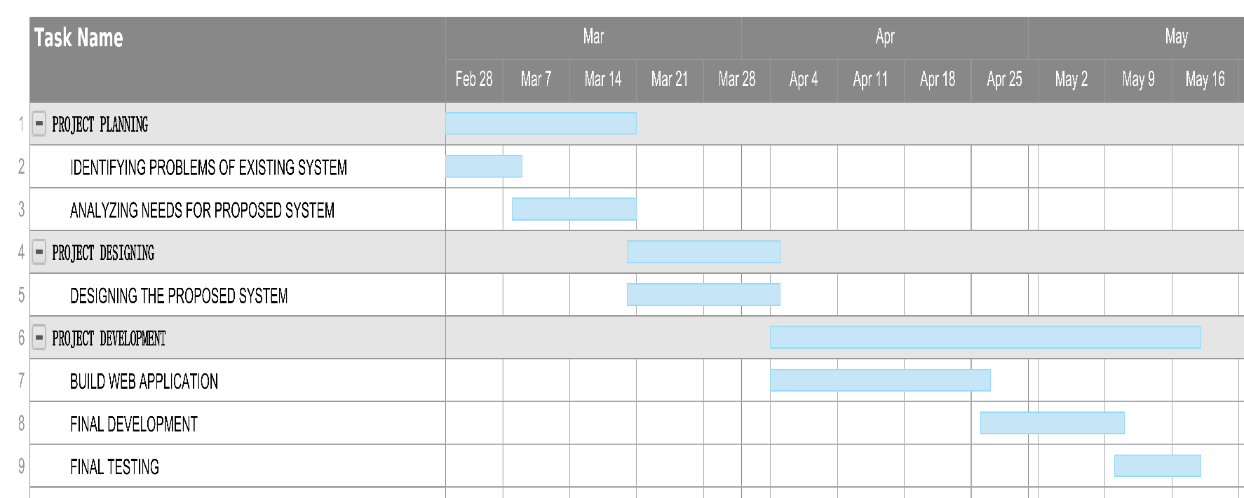

## 3.4 Process/Activity wise Resource Allocation

Now talking about Process/Activity wise Resource Allocation. My Process/Activity wise Resource Allocation chart is given below. There is my task combination. I always want to do submit my work on time and complete as much as possible.

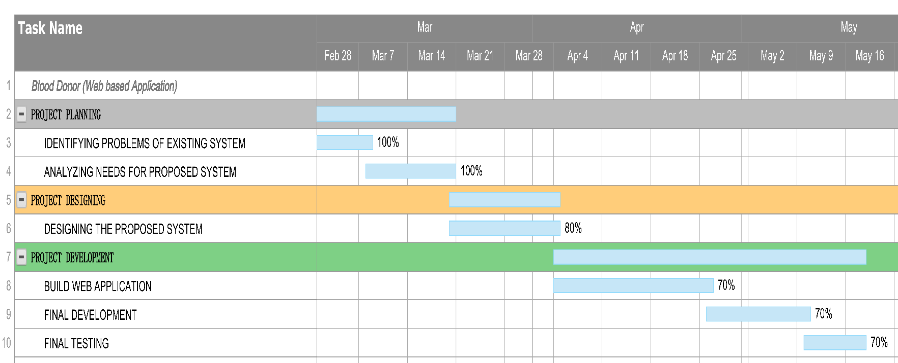

## 3.5 Estimated Costing

|  |  |
| --- | --- |
| Project: BLOOD DONOR | |
| COSTING | |
| ITEM | COST (TK) |
| HOSTING (HOSTINGER) | 8245 |
| DOMAIN (.TK) | FREE FOR 1 YEAR |
| SSL | COMPLEMENTARY WITH HOSTING |
| TOTAL | 8245 |

For the proposed system, domain hosting were needed for web applications. All these resources were provided by the company for the project completion.

# Chapter 4 Methodology

The Blood Bank web application is following the methodology of the Iterative Waterfall Model. The internet has had a significant impact on the process of web developing information system. However there has been little research. Nowadays through the internet anybody can access any site and order to receive blood. So, this user-friendly project i am using Html, CSS, Bootstrap, PHP to build. It is responsible from any device like smartphone, Laptops, computer, Tablets and so on. After using Bootstrap, it can be visible for any ratio of screen.

**Html**-It gives the basic structure of the project. It is actually browser friendly code .everything is visible in your browser and can add logo, buttons, using this HTML code.

**CSS-**It gives the style of the project. It gives the shape and size of the project. Have to add a stylesheet on HTML file rather than it not working or can't give you the beauty which your project and clients want from you.

**Bootstrap-** Basically, Bootstrap is not a code it removes your ratio problem that the main reason it can access from any device and any ratio screen. Any screen ratio it's not a problem when you use bootstrap.

**PHP**- using this PHP i created front end and back end, the full project and image and text is used in PHP format that helps me to connect to the database.

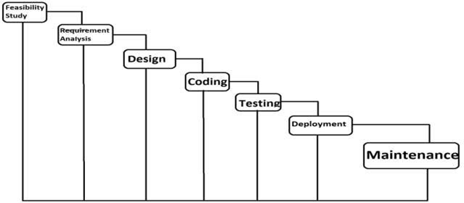

**Advantages:**

* Easy to understand and implement.
* Testing in each phase.
* Documentation Available after each phase.
* In an iterative model less time spent on documenting and more time is given for designing.

**Disadvantages:**

* Once detecting error at any face it may be required that the precede subsidy faces may change.
* Very difficult to manage changes b/w the phases there is the possibility of blocking which can slow down the productivity and efficiency of the process.
* Risk is not addressed in this model**.**

**Advantage of Model in this System**

* Easy to understand.
* It is the basic model of all models.
* Errors are detected after each Phase of Development.
* It is a Single and Small Project
* It is easily adaptable to the ever-changing needs of the project as well as the client.
* Small teams work better using agile development process as on developer can
* possess multiple skills and can utilize them at several stages of the iteration
* without conflicts.

# Chapter 5 Body of the Project

## 5.1 Work Description

In my project I have simple things on it. First of all, I have developed the user interface and see how it looks. Create responsive home button and give the main BloodBank home Link. Add services of our company which give users vast knowledge about, who can donate blood, and who can receive blood and available blood samples. It also shows health tips for patients. The normal thing every website has about us.

Gives the basic contact with us, location of our company, social media icon (so the patients can use our Facebook page, and communicate with us 24hrs.),email address. The basic Privacy policy and terms and conditions.

## 5.2 System Analysis

### 5.2.1 Six Element Analysis

|  |  |  |  |  |  |  |
| --- | --- | --- | --- | --- | --- | --- |
| **System Roles** | | | | | | |
| **Process** | **Human** | **Non- Computing Hardware** | **Computing Hardware** | **Software** | **Database** | **Communication & Network** |
| Access Resources | Customers  -View the resources | N/A | -  Necessary device s (e.g., pc, laptop, phone) | -Browser  -Website | -Stores all the resources DBMS((SQL) | -  Internet/broadband  - Mobile data |
|  |  |  | -  Internet cable |  |  |  |
| Communication between customers | Customer  -Through social media | -N/A | -  Necessary device s (e.g., pc, laptop, phone) | -Browser  -Website | - Stores all resources DBMS((SQL) | -  Internet/broadband  - Mobile data |
|  | | | | | | |

### 5.2.2 Feasibility Analysis

Feasibility study is made to see if the project on completion will serve the purpose of the organization for the amount of the work, effort and the time that spend on it. Feasibility study lets the developer for see the future of the project and the usefulness. A feasibility study of the system proposal is according to its workability, which is the impact on the organization, ability to meet their user needs and effective use of resources. As the name implies, a feasibility study is used to determine the viability of an idea, such as ensuring a project is legally and technically feasible as well as economically justifiable. It tells us whether a project is worth the investment in some cases, a project may not be doable. Feasibility studies allow companies to determine and organize all the details to make a business work. A feasibility study helps identify logistical problems, and nearly all business related problems and their solutions. Feasibility studies can also lead to the development of marketing strategies that convince investors or a bank that investing in the business is a wise choice.

The feasibility study is performed to determine whether the proposed system is viable considering the Technical, Operational and Economical factors. After going through feasibility study we can have a clear-cut view of the system’s benefits and drawbacks.

Technical Feasibility:

The proposed system is developed using Active Server Page, VB Script and HTML as front-end tool and Oracle 8 as the back end. The proposed system needs a Personal Web Server to serve the requests submitted by the users. The Web browser is used to view the web page that is available within the Windows operating system itself. The proposed system will run under Win9x, NT, and win2000 environment. As Windows is very user friendly and GUI OS it is very easy to use. All the required hardware and software are readily available in the market. Hence the system is technically feasible.

Operational Feasibility:

The proposed system is operationally feasible because of the following reasons.

* The customer is benefited more as most of his time is saved. The customer is serviced at his place of work.
* The cost of the proposed system is almost negligible when compared to the benefits gained.

Economic Feasibility:

As the necessary hardware and software are available in the market at a low cost, the initial investment is the only cost incurred and does not need any further enhancements. Hence it is economically feasible.

The system is feasible in all respects and hence it encourages taking up the system design.

### 5.2.3 Problem Solution Analysis

The problem solution Analysis are:

* Develop a feasible solution to handle management activities in blood banks.
* Create an effective means of communication between donors, hospitals, donors, and recipients.
* Device means of coordinating the activities of blood banks and blood donation centers.

### 5.2.4 Effect and Constraints Analysis

The system that is going to be developed is Online Blood Bank. This is a web-based database application system that is to be used by the blood banks or blood centers to advertise the nationwide blood donation events to the public and at the same time allow the public to make online reservation and request for the blood. The system keeps the record of all the donors, recipients, blood donation programs, rejected bloods. This project intends to computerize the blood and donor management system in a blood bank to improve the record management efficiency due to the grown size of records of data.

**Benefits:**

· Record are secured and stored

· Easy to search the required blood

· Easy to manage the blood stock details

· Fast service.

**Goals:**

1. To provide a means for the blood bank to publicize and advertise blood donation programs.

2. To allow the probable recipients to make search and match the volunteer donors, and make request for the blood.

3. To provide an efficient donor and blood stock management functions to the blood bank by recording the donor and blood details.

4. To improve the efficiency of blood stock management by alerting the blood bank staffs when the blood quantity is below it par level or when the blood stock has expired.

5. To provide synchronized and centralized donor and blood stock database.

6. To provide immediate storage and retrieval of data and information.

## 

## 5.3 System Design

### 5.3.1 Rich Picture

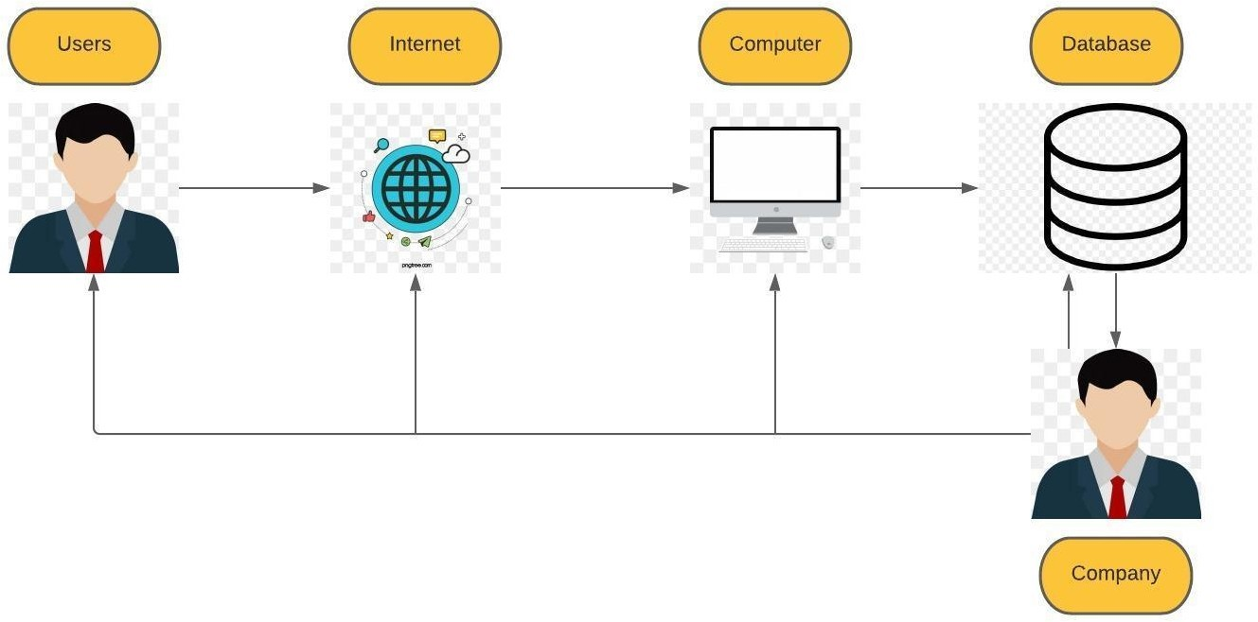

### 5.3.2 UML Diagrams

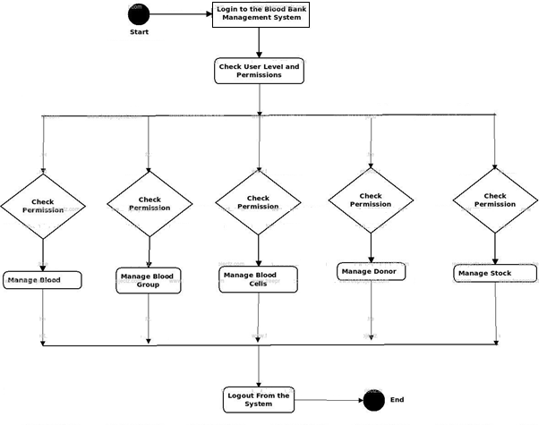

### 5.3.3 Functional and Non-Functional Requirements

There are a lot of software requirements included in the functional requirements of the Blood Bank l Management System, which contains various processes, namely Registration, Check out, Report Generation, and Database.

**Registration Process**

* Adding Patients: The Blood Bank Management enables the staff in the front desk to include new patients to the system.
* Assigning an ID to the patients: The Blood bank enables the staff in the front desk to provide a unique ID for each patient and then add them to the record sheet of the patient. The patients can utilize the ID throughout their hospital stay.

**Report Generation**

* Mandatory Patient Information: Every patient has some necessary data like phone number, their first and last name, personal health number, postal code, country, address, city, 'patient's number, etc.
* Updating information of the Patient: The Blood bank management system enables users to update the information of the patient as described in the mandatory information included.

**Non Functional Requirements**

There are a lot of software requirements included in the non-functional requirements of the Blood Bank Management System, which contains various processes, namely Security, Performance, Maintainability, and Reliability.

**Security:**

* Patient Identification: The system needs the patient to recognize herself or himself using the phone.
* Logon ID: Any users who make use of the system need to hold a Logon ID and password.
* Modifications: Any modifications like insert, delete, update, etc. for the database can be synchronized quickly and executed only by the ward administrator.
* Front Desk Staff Rights: The staff in the front desk can view any data in the Blood Bank Management system, add new patients records to their system but they don't have any rights to alter any data in it.
* Administrator rights: The administrator can view as well as alter any information in the Blood bank Management System.

**Maintainability:**

* Back-Up: The system offers the efficiency for data back up.
* Errors: The system will track every mistake as well as keep a log of it.

## 5.4 Product Features

### 5.4.1 Input

Here are the product features inputs of my project “Blood Donor – a web based Blood Bank”. You can see all the inputs to the system and the picture illustrating the process to make understanding more clear.

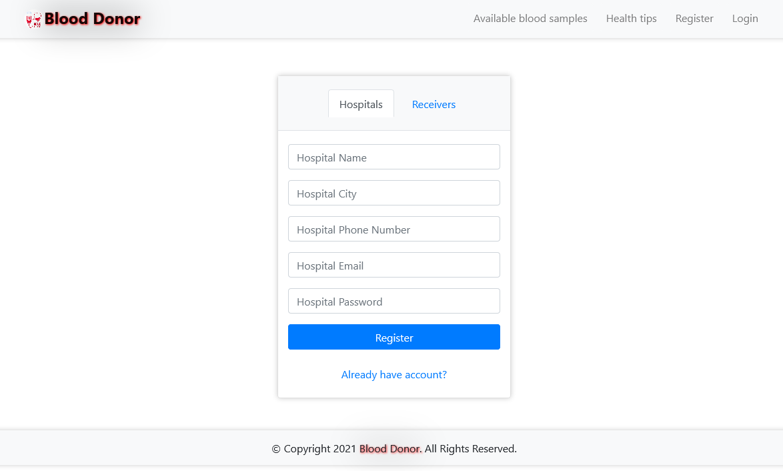Figure: Hospital Registration page

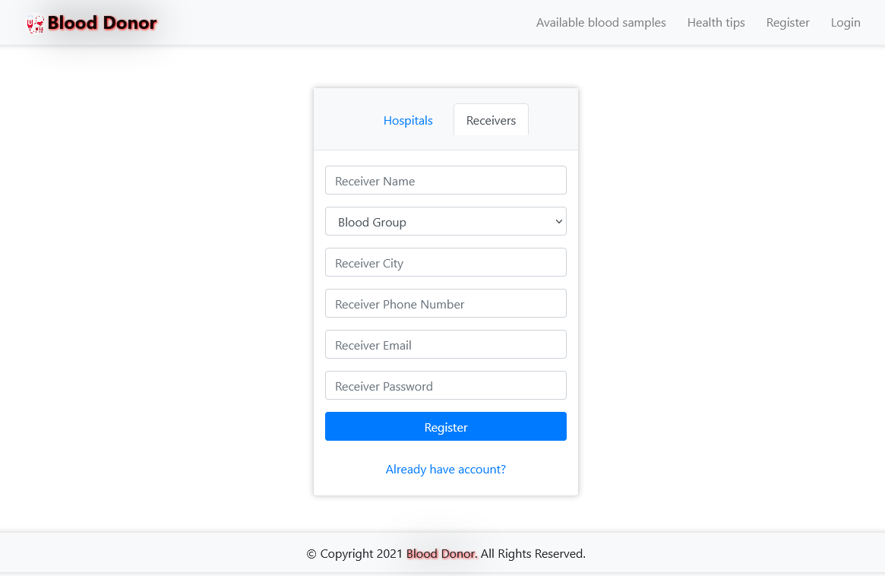Figure: Receiver Registration page

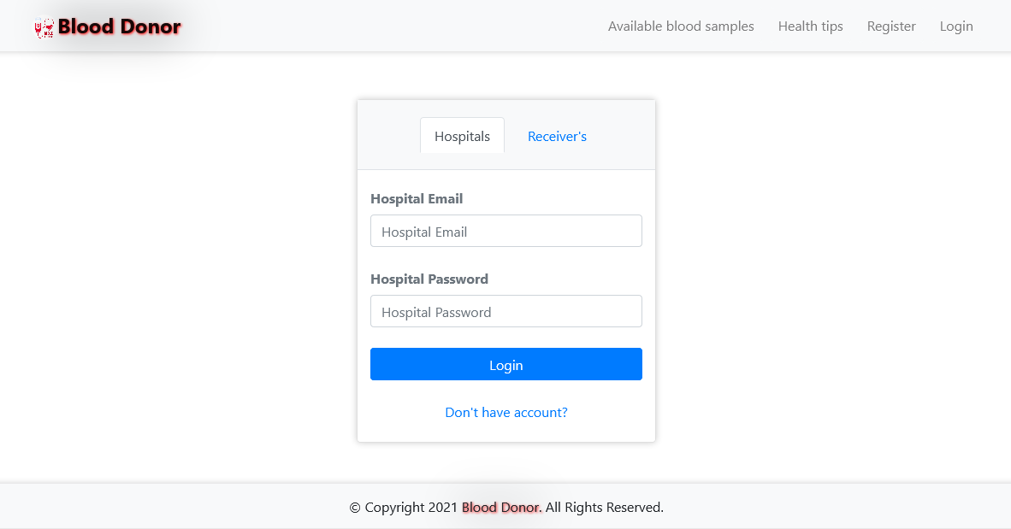Figure: Hospital login page

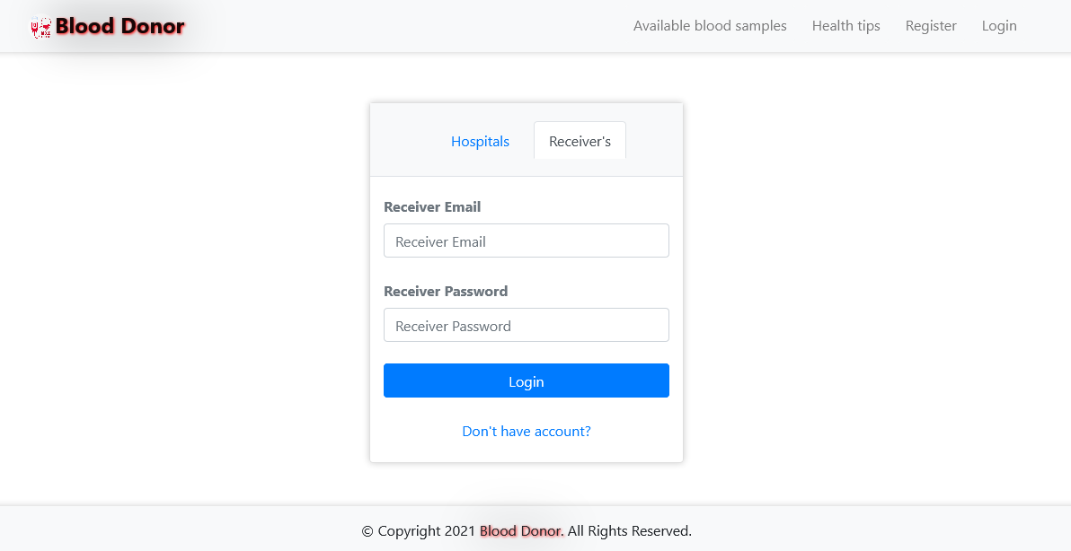Figure: Receiver Login page

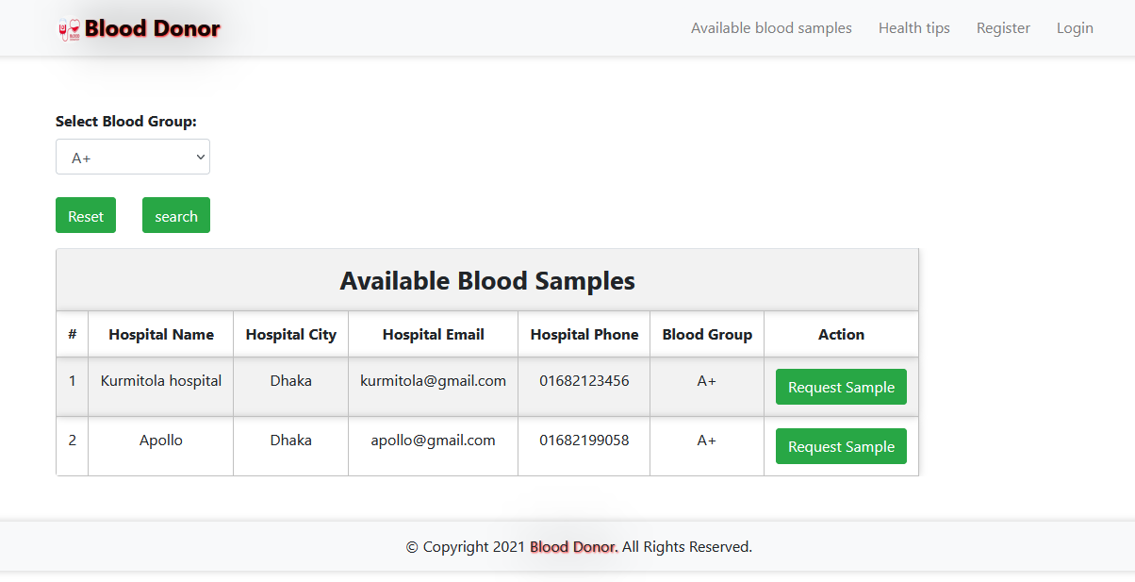Figure: Searching for a specific blood group.

### 5.4.2 Output

Here are the product features outputs of my project “Blood Donor – a web based Blood Bank”. You can see all the outputs of the system and the picture illustrating the process to make understanding more clear.

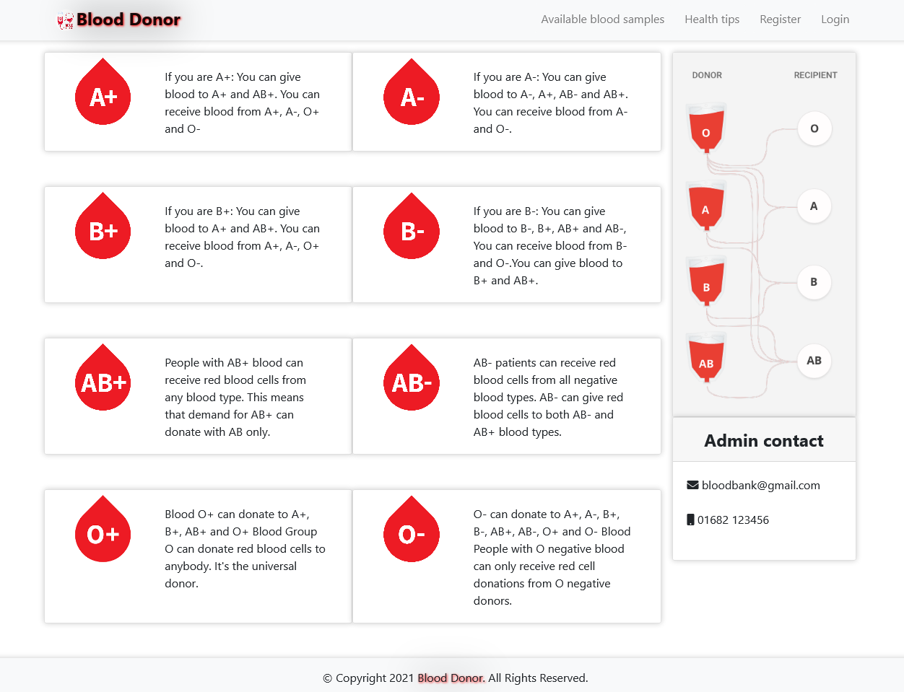

Figure: Home Page

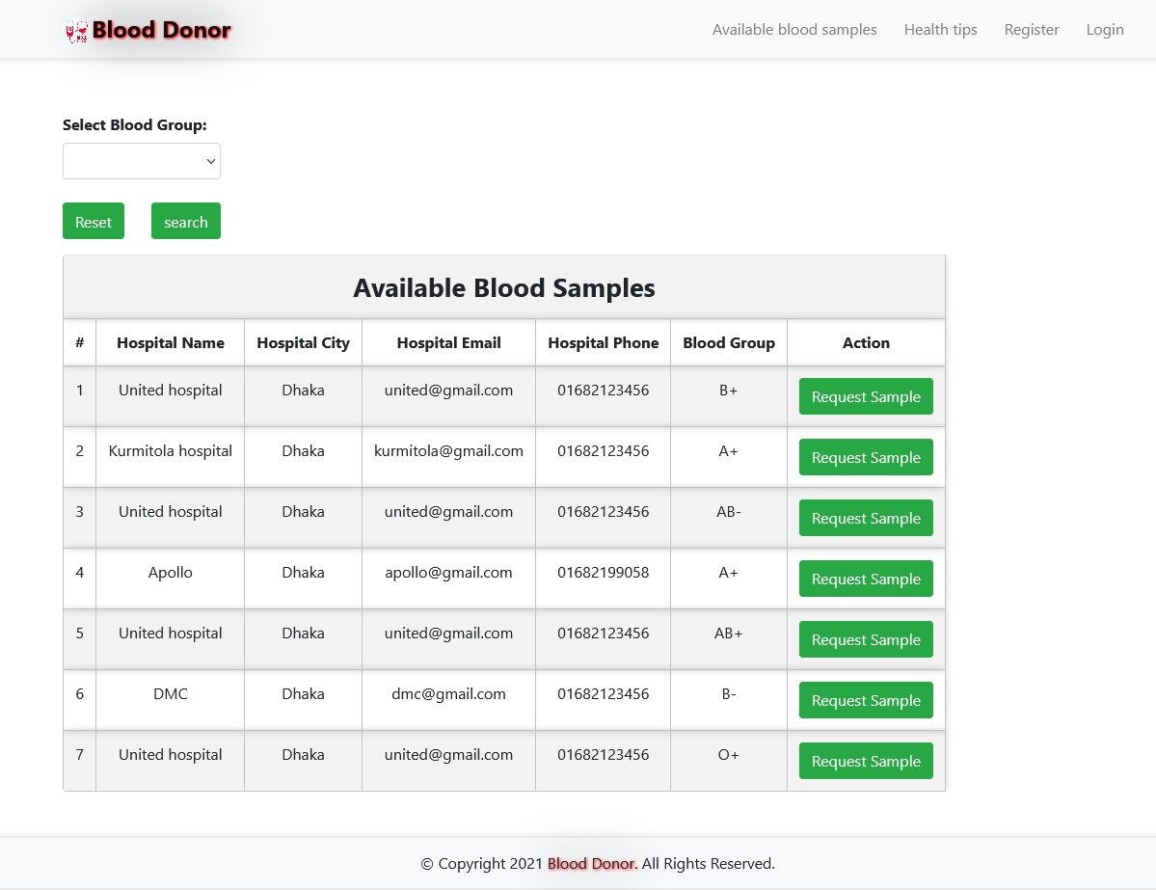

Figure: Available blood Samples

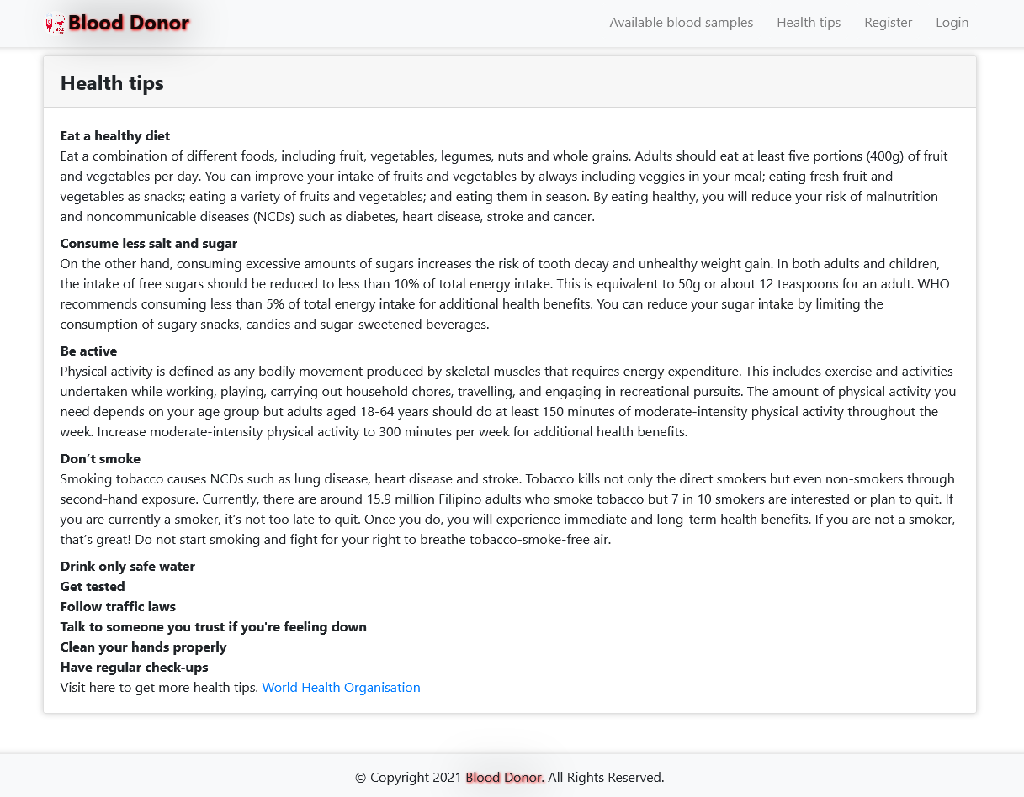

Figure: Health Tips (Blogs)

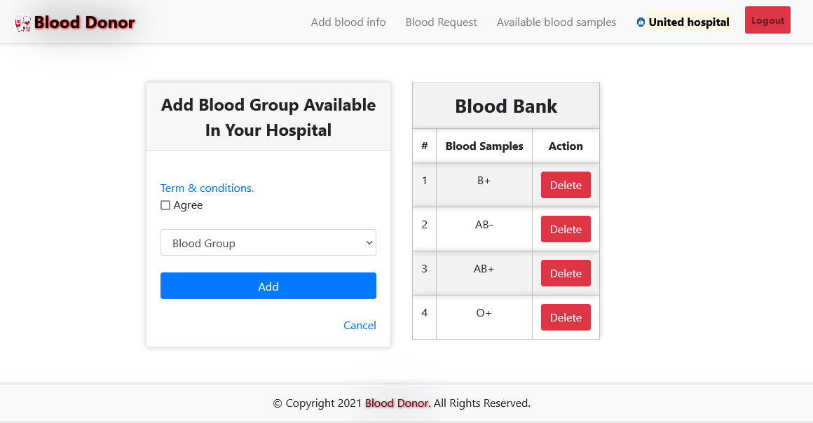

Figure: Add available blood group (Only Hospital Access)

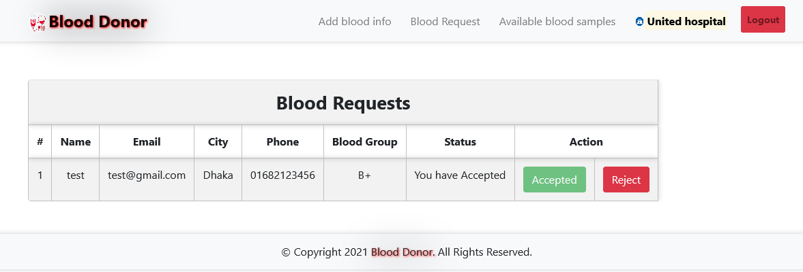

Figure: Blood Requests (Only Hospital Access)

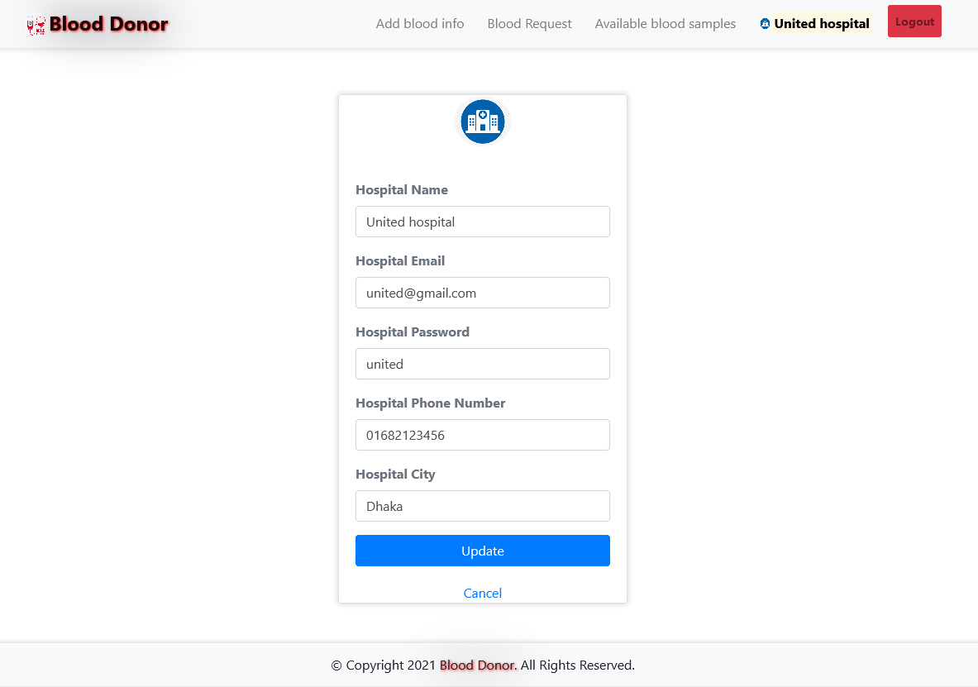

Figure: Hospital Registration Information Update page

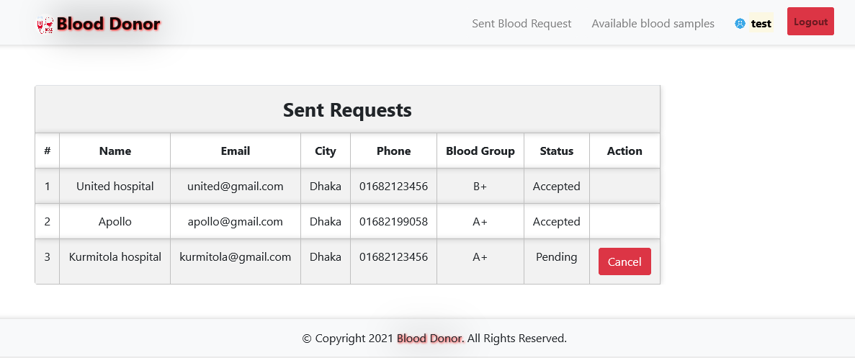

Figure: Sent Requests (Receiver Access)

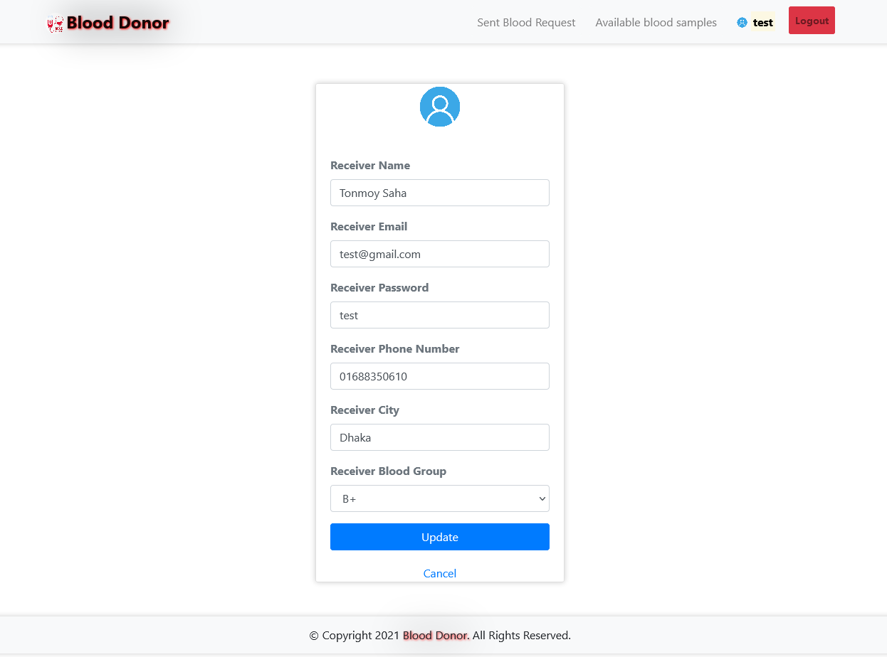

Figure: Receiver Registration Information Update page.

### 5.4.3 Architecture

Our new system will be a website hosted on an apache web server. The overall architecture is centralized. In this sense, the system is deployed in a central server while being accessed and collecting data from browsers on different devices in distributed areas.

Unlike the existing blood bank management systems, the new system is designed to be used by different blood bank centers while maintaining data security and privacy of individual blood banks but at the same time having the same level of access to other data and information like donors’ and recipients’ information.

The new system is designed to be “deployed once and use anywhere” as opposed to some researches that suggest management activities to be implemented on standalone systems that will be deployed on individual computers in the blood bank centers. All System functionalities will be accessible over the internet depending on the type of user accessing the system.

# Chapter 6 Results & Analysis

Here are the product results and Analysis of my project “Blood Donor – a web based Blood Bank”. You can see all the results of the system and the picture illustrating the process to make understanding more clear.

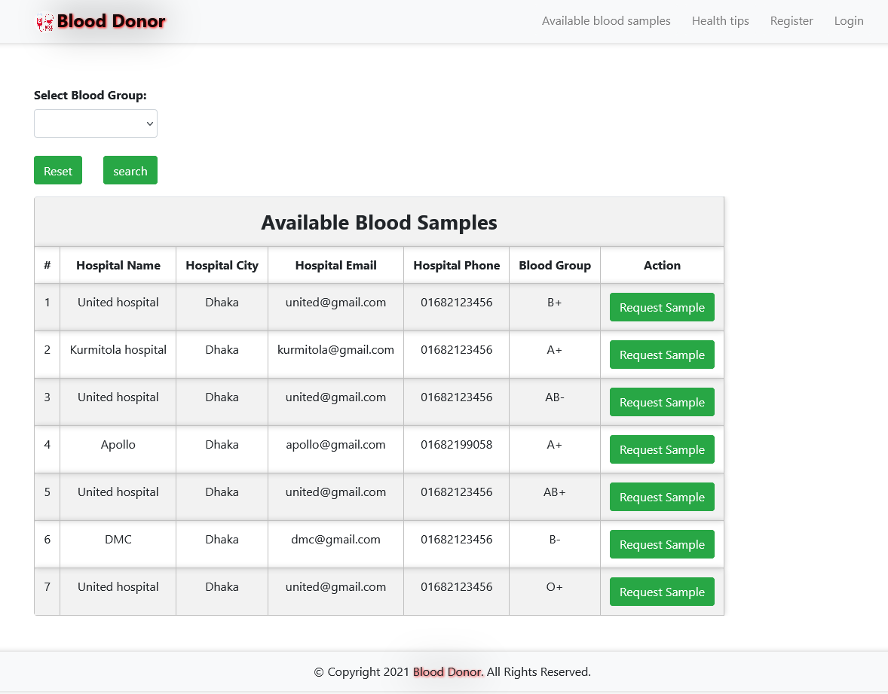

Figure: Available blood samples with hospitals list

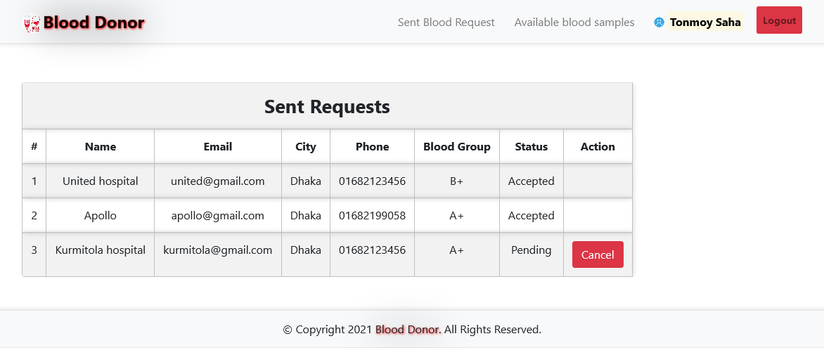

Figure: Request sent by blood receivers (who needs blood)

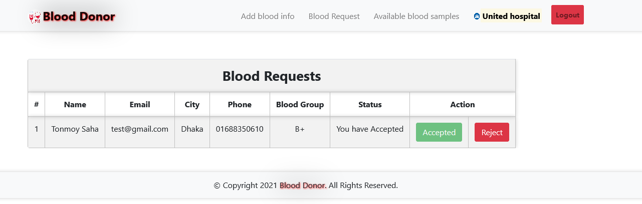

Figure: Blood request view and accept/reject portal for hospitals.

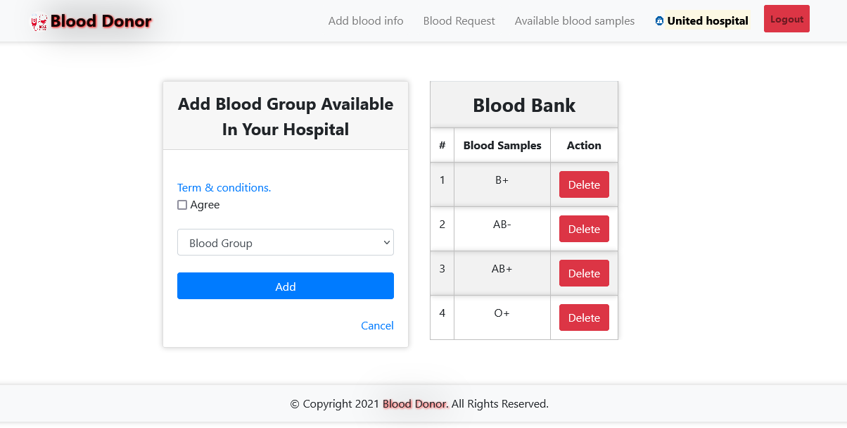

Figure: Add available blood groups by Hospitals.

# Chapter 7 Project as Engineering Problem Analysis.

## 7.1 Sustainability of the Project/Work

Some positive factors, which will ensure the sustainability of the project, include:

* Increase in budgets for the National Blood Transfusion Service from year 2007, as indicated by the MOH.
* Existence of a network to transfusion specialists in Dhaka, who will be willing to assist further development.
* Implementation of the new National Strategy on Blood Safety and Donations on Blood Services will improve operation of blood banks.
* Risks that may hinder sustainability of project achievements include:
* Lack of capability to organize a true nationwide Service.
* Lack of a clear plan for implementing a National Blood Transfusion Service with its allocated budget, especially serving the rural areas of the country.

## 7.2 Social and Environmental Effects and Analysis

Blood transfusions are an important aspect of medicine and safety of this product is paramount. Infections transmitted by transfusions can result in complications and represent a major public health concern. Developed regions have managed to minimize this risk through various approaches including donor screening and deferral; however, as pointed out by Flaherty further risk reduction can be achieved by improving strategies of blood screening and pathogen inactivation. An approach based upon a (self-reported) questionnaire as a standard procedure to screen potentially contaminated blood donors may not be enough in the case of diseases without an effective blood screening test. Furthermore, a deferral strategy due to previous travel may inappropriately exclude a large number of potential blood donations. Flaherty examined the feasibility of relaxing the blood donation restrictions for some infectious diseases on the basis of available evidence, suggesting little risk of transfusion-transmitted infections when travelling to certain locations.

As mentioned earlier, one of the major factors influencing the changing geographic distribution of many infectious diseases is climate change favorable to vectors. A varied distribution of infectious diseases due to climate change favorable to vectors is also becoming a major issue in the evaluation of blood donors. Some communicable diseases, such as the Zika virus, are of particular concern, since a large number of infected people may be asymptomatic and present themselves as a health donor. This becomes even more critical when sensitivity and specificity of screening has not been well established. Even greater concern exists for diseases that do not have an effective and efficient testing protocol. This can eliminate a large number of suitable blood donors solely on the basis of travel history. Most questionnaires evaluate donors based on foreign travel, but with the spread of infectious diseases this concept may also be changing. As seen with many emerging infections (e.g. Zika virus, Babesiosis, Chagas disease) transmission can also result in issues of travel even within a geographical region (e.g. the USA); thus, extending concerns for the blood supply to those travelling within a country. These occurrences will require a new strategy in selecting blood donors.

# The health and social impact of Blood Donors Associations: A Social Return on Investment (SROI) analysis:

* Blood donor associations generate positive quantifiable benefits to their members.
* The overall blood donation or volunteering experience brings positive changes.
* SROI is applied to the investigation of phenomena which are still little explored.
* Soft impacts of donation such as social and human capital can be quantified.
* Social impact evaluation in nonprofit organizations opens to [stakeholder engagement](https://www.sciencedirect.com/topics/social-sciences/stakeholder-engagement).

## 7.3 Addressing Ethics and Ethical Issues

As web developers, we are responsible for shaping the experiences of user's online lives. By making choices that are ethical and user-centered, we create a better web service for everyone.

**Ensuring Blood Quality:** To make sure only health human blood is delivered and there is no contamination in blood. So that no bad blood is collected or delivered or bought for higher profits.

**Ensuring Right Blood Type:** Ensuring right blood group and test for blood (disease free). This is important as many drug addicted persons wants to donate blood for money. Blood from them can cause health issues.

**Web applications should work for everyone**

* Built on top of progressive enhancement
* Prioritize accessibility
* Develop inclusive forms
* Test with real users

**Web applications should respect a user's privacy and security**

* Use https everywhere
* Respect user tracking preferences
* Provide users with clear information about how their information is used
* Allow users to export their data
* Secure user data

# Chapter 8 Lesson Learned

## 8.1 Problems Faced During this Period

During my Internship period at JBL Drug Laboratories there were many problems that I had to go through. The first was the Covid19 period made it risky to travel to work station. I had to do work from home during the lockdown period. When doing work from home, interactions with seniors and colleagues became little difficult and many faced network problems and issues while doing google meet meetings and discussions.

Learning from the work environment was also very difficult as I had to take and understand my work with extra efforts. The colleagues are helpful but has their own deadlines to meet so are often busy.

Physical office was more preferable as I could connect with senior officers and developers. But due to Covid19 concerns, internship sessions were mostly conducted online as work from home to minimize the spreads of disease.

In my opinion 3 months are not proper for adapt and understand the overall work flow and operations of a company which is involved with so many different projects and different department. For lockdown our office in closed since last of April. In this time, we work from home. It was little challenging but we done us in online. In this case we use Discord and google classroom for meeting. Is was less time consuming but some problem was there.

It was very difficult for me to maintain work progress as like as other team members. Since they are very experienced and good at their work. I had to work like a full-time employee as my office time was 9:30 am to 5:30 pm. Since I don’t have any experience that’s why it was challenging for me but I enjoy it.

## 8.2 Solution of those Problems

Although most of the problem faced at JBL was mostly due to work from home and Covid19 pandemic. But I believe these problem will get solved when the pandemic ends. My supervisor helped me a lot and guided me to every task. Having such helpful supervisor also solved many problems. But there are always scope from improvement. Below are some recommendations for improvements and problem solutions.

After completing the internship in JBL Drug Laboratories IT Department, I have some recommendation for this training and development in this department. These are:

• **Promotional activities:** Though they work with so many projects and which are more than enough for this company. Still my recommendation will be more focused on promotional activities.

• **Emphasize training as an investment:** While the initial costs may seem high, stress within your company that training is a long-term investment in the development of your staff.

• **Maintenance of the systems:** Since JBL Drug IT Department work for many systems for their operation and clients, so they need watchful maintenance of the systems by the responsible management.

• **Maintain standard quality of products:** They should maintain standard quality of products and services.

• **Target your needs:** Identify the specific skills you need to improve and the timeframe within which you'd like to meet your training goals to provide the optimal payback.

• **Encourage a learning culture:** Express to all employees that your organization cares about enhancing their skills and wants every worker — whether training or not — to remain competitive within their skill set.

• **Select high-quality instructors:** Make sure the trainers hired are professional educators and that their materials can serve as valuable resources in the future.

• **Make it a continuous process:** Don't limit your training to new employees, and try to bring in as many workers as you can who would benefit from additional training.

• **Track the results:** A training program won't be effective unless you monitor its progress. Choose a metric, such as productivity or profit, to help determine the return on investment for your training efforts and establish concrete results.

# Chapter 9 Future Work & Conclusion

## 9.1 Future Works

In light with the current development in computing where everything is moving to cloud technology, our CBBR system is developed with the future in mind and it is therefore scalable and can easily be transformed into a cloud server that various blood banks can tap into and get required data and utilize various functionalities.

On a short-term basis however, we are looking into SMS integration, where alerts and notifications will be sent to users' mobile phones.

* Make Donor categories A, B or C based on lifestyle and fitness.
* Direct Donor to Receiver connection.
* Real time tracking of Blood bag delivery (Like Uber)
* SMS service support
* Chat Service Support
* Connect to the Hospital software via API to our Web system

## 9.2 Conclusion

Prior to this project and report, a general study of the blood bank management system was conducted from recent research of various authors and facts were gathered which helped to uncover the misfits that the system was facing. After proper analyzation of these problems, a solution was then developed in order to meet up the needs of a more advanced system. This system is known as the centralized blood bank repository which helped in eliminating all the problems that the previous systems were facing. With this system, Blood banks/Centers, Hospitals, Patients and Blood donors will be brought together to enjoy a large number of functionalities and access a vast amount of information, thereby making blood donation and reception a lot easier and faster.

# Bibliography

1. Catassi, C. A., and E. L. Peterson. "The Blood Inventory Control System—Helping Blood Bank Management through Computerized Inventory Control*." Transfusion 7.1 (1967): 60-69.
2. Ekanayaka, E. M. S. S., & Wimaladharma, C. (2015). Blood bank management system. Technical Session-Computer Science and Technology & Industrial Information Technology, 7.
3. Esah, P., & Ab Rahman, S. (2011). Blood Bank Management System. [Accessed 22 Feb. 2015].
4. Nzoka, M. and Ananda, F. (2014). Blood Bank Management Information System A Case Study of the Kenya National Blood Transfusion Services. Proceedings of Sustainable Research and Innovation Conference, [online] pp.146-149. Available at:http://www.jkuat-sri.com/ojs/index.php/proceedings/article/view/110 [Accessed 20 Feb. 2015].
5. Who.int, (2015). WHO | Blood safety and availability. [online] Available at: http://www.who.int/mediacentre/factsheets/fs279/en/ [Accessed 24 Feb. 2015].
6. Library.med.utah.edu, (2015). Blood Bank. [online] Available at: http://library.med.utah.edu/WebPath/TUTORIAL/BLDBANK/BLDBANK.html [Accessed 25 Feb. 2015].
7. Anon, (2015). [online] Available at: http://www.who.int/worldblooddonorday/campaignkit/WBDD_GlobalNeed_English.pdf [Accessed 26 Feb. 2015].
8. Wake, D. J., & Cutting, W. A. M. (1998). Blood transfusion in developing countries: problems, priorities and practicalities. Tropical doctor, 28(1), 4-8.
9. Dzik, W. H., Corwin, H., Goodnough, L. T., Higgins, M., Kaplan, H., Murphy, M., & Yomtovian, R. (2003). Patient safety and blood transfusion: new solutions. Transfusion Medicine Reviews, 17(3), 169-180.
10. Dzik, W. H. (2003). Emily Cooley Lecture 2002: transfusion safety in the hospital. Transfusion, 43(9), 1190-1199.